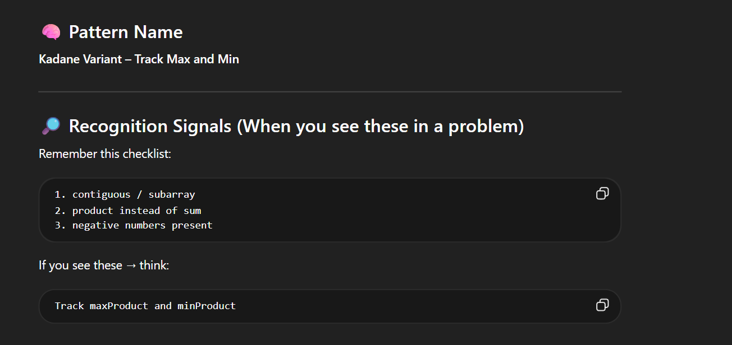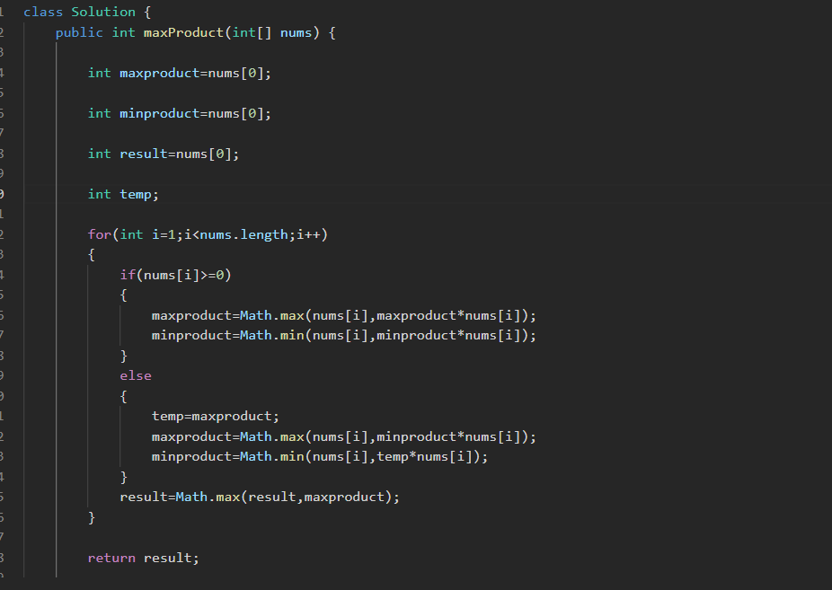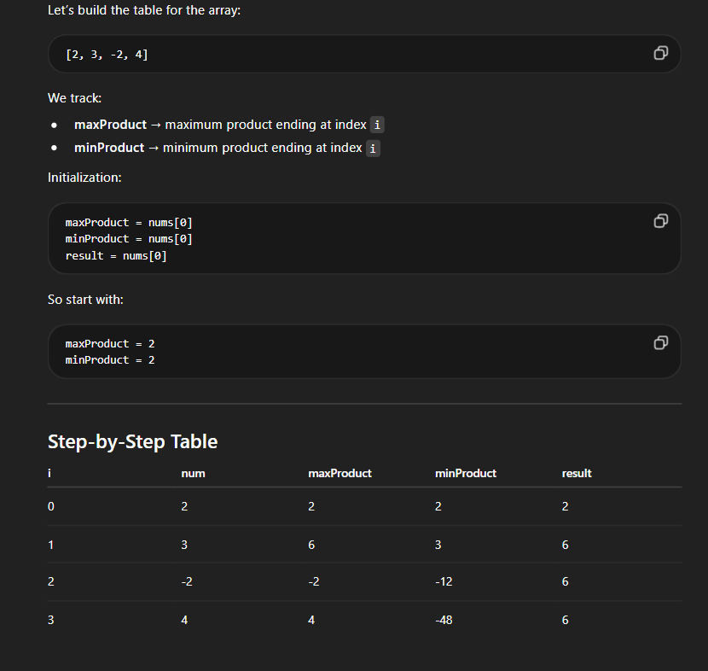

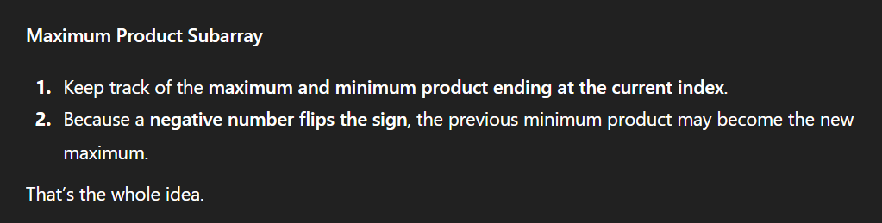

If nums is < 0 then multiplying the min with that negative num make it larger and the min is get by multiplying the max with negative num

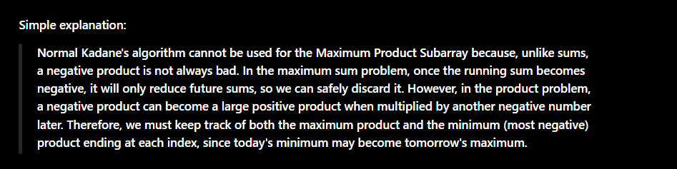

LINK:
https://leetcode.com/problems/maximum-product-subarray/submissions/1938728736

